PCI

SPECIAL REPORT Oct. 27, 2011

Florida’s Automobile No Fault Insurance:

A System Under Siege by Fraud and Abuse

Executive Summary

Over the last several years, pervasive fraud in Florida’s no fault auto system has cost consumers over $800 million. Fraud costs have been rapidly exploding, are far worse here than in other states, are particularly bad in certain Florida counties, and will greatly increase insurance costs for consumers if not swiftly brought under control. While important change is always difficult to accomplish, there is a growing recognition among policy leaders and insurance consumers in Florida that the current system is unsustainable, and honest consumers and businesses need to be better protected.

Florida’s no fault system was created with the intent of providing affordable, quick and fair compensation to accident victims, without regard to fault. Regrettably, the Florida no fault system is completely broken. There are more auto lawsuits in Florida than other no fault states, rates are climbing due to accelerating underlying costs, and rampant fraud is leading to a two-tiered system with most honest Florida consumers paying for the unnecessary medical bills and sky-high attorney fees of those taking advantage of the system.

Florida’s no fault claim costs, which pay for medical care, have far outpaced those of other no fault states and the cost of medical care. Florida drivers pay the highest liability premium in the nation, even though premium payments are increasingly inadequate in relation to skyrocketing fraud costs. Unless something is done to contain the ever-increasing no fault losses and expenses, the fraud tax will grow even larger and honest consumers and businesses will continue to get stuck with the tab.

While Florida’s no fault system is complicated, the areas rife with fraud are easy to identify and the solutions straightforward. There are four essential fraud-fighting fixes that can be quickly enacted:
- Allowing a reasonable amount of time to investigate suspicious claims.
- Eliminating incentives for frivolous no fault lawsuits by placing caps on attorney fees.
- Providing greater oversight of medical clinics by allowing private on-site inspections of premises to ensure the services are real.
- Preventing fraudulent unnecessary medical treatment by establishing reasonable treatment limits.

$800 Million Fraud Tax Imposed on Consumers

There is an epidemic of insurance fraud in Florida, and consumers are paying for it in the form of higher premiums. In the last several years, the number of auto claims has gone up dramatically despite a significant decline in auto crashes. Medical billings to cover insured injuries are rapidly increasing far beyond the cost of medical care or treatment costs in other states, resulting in what Florida Insurance Commissioner Kevin McCarty labels an $800 million fraud tax on consumers since 2006.

This tax is imposed on consumers when fraudulent health care clinics perform diagnostic tests on those involved in staged accidents and unnecessary diagnostic tests on those involved in legitimate accidents, taking business away from legitimate providers. It is imposed when claimants refuse to appear for scheduled exams or answer questions under oath about their treatment. It is imposed when fraudulent trial lawyers enrich themselves with huge attorney fees while leaving injured victims with less. And it is imposed when insurers raise rates to close the gap with rapidly increasing fraud costs.

The Highest Liability Premium in the Nation

Florida drivers currently pay the highest auto liability insurance premium in the nation, 56% more than consumers in other states (annual premiums of $736 – FL vs. $471 – US). Not only do Florida consumers suffer the highest costs for liability coverage in the United States, but Floridians also get stuck paying the most relative to what they earn. The average Florida household spends over 1.6% of its income on auto liability insurance, almost twice as much as the national average of 0.9% of household income.

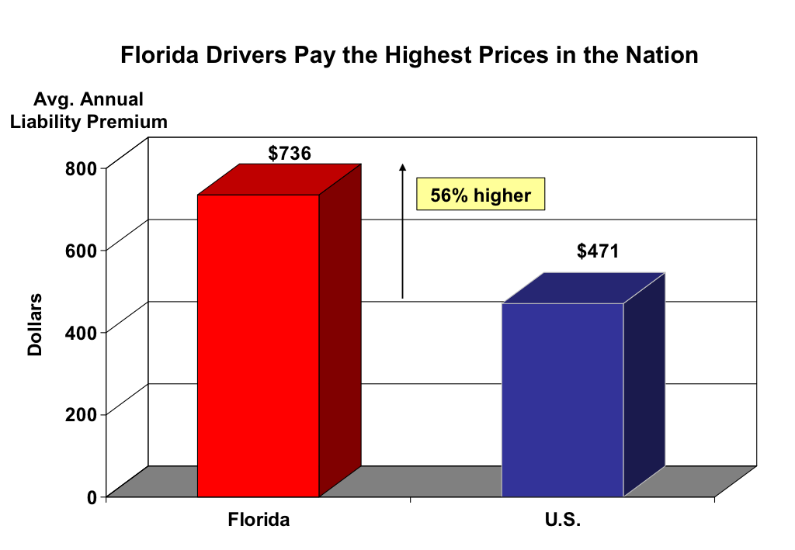

The amount consumers pay for insurance is primarily determined by the expected number of claims, the cost of these claims and settlement expenses (e.g., litigation costs, claims review, etc.). One reason for Florida’s very high liability premium is the fact that its third party bodily injury claim frequency has increased dramatically, rising 19.2% from 2006 to 2010. In contrast, the frequency for tort states has remained fairly flat overall and the frequency for other no fault states has been declining. The increase in Florida’s bodily injury claim frequency is especially apparent beginning in 2008, about the same time as the start of the financial crisis when total miles driven fell.

Skyrocketing No Fault Costs

While the number of auto accidents in Florida has been decreasing, the number of no fault claims has been increasing along with the number and charges for non-emergency medical bills. This is inconsistent with no fault systems that are intended to reduce medical costs, providing first party benefits in exchange for limitations on tort rights.

The following no fault claim and loss patterns are observed over the last five years:

- The number of claims increased by almost 5% in Florida compared to a decrease in other no fault states.

- Florida's average claim cost increased by 38.3%, twice as fast as other no fault states.

- Together, Florida’s average loss per insured car (i.e., loss cost) has increased at a rate more than double other no fault states.

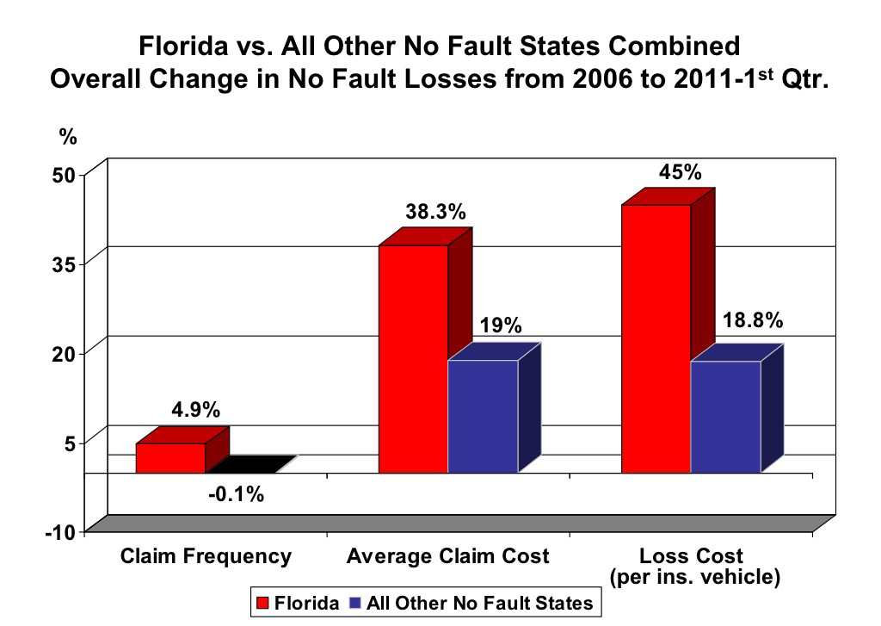

Fraud Exaggerates Auto Injury Costs

Insurance fraud impacts all Floridians by raising the average cost of claims, and it tends to get worse during times of financial difficulty. Rampant insurance fraud is illustrated by comparing the increases in Florida's no fault auto injury claim costs and medical care costs.

- Florida's no fault auto injury costs have increased more than twice as fast as the US medical care inflation rate since 2006. These injury costs began materializing at an increasing rate in 2008.

- Michigan, New Jersey and New York are three other states known for extreme no fault insurance fraud. Florida's auto injury costs have far outpaced the combined results even for these three states.

- Florida fraud is most apparent when its spiking injury cost growth is compared to other states with no fault auto injury systems which have grown in tandem with inflation.

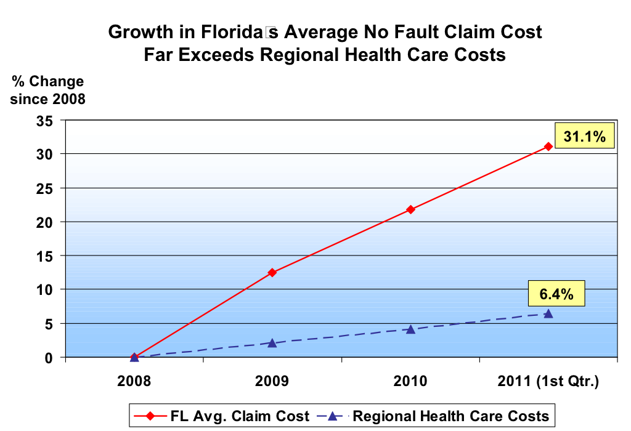

Growing Fraud Tax Contributes to

Growing Losses and Expenses that Exceed Premiums

Over the last four years, total auto liability losses and expenses to investigate and settle claims (Loss Adjustment Expenses or LAE) as well as underwriting expenses to operate the business (e.g., administrative, sales, taxes, license and fees, etc.) have grown so much that the premiums collected by insurers have increasingly not been able to cover these amounts. This has resulted in a $1.2 billion gap in 2010; rising consumer costs could result in even larger gaps over time.

As long as the number and amount of fraudulent claims continue to escalate in Florida, higher liability loss trends are likely to go on as well. In 2010, the total liability losses and LAE to pay for and settle claims were $8 billion; about one-third of this amount ($2.68 billion) reflects no fault losses and LAE. If recent increases persist, total liability losses and LAE are expected to reach $9.1 billion in 2013. No fault losses and LAE are anticipated to increase faster due to rapidly rising fraud costs. By 2013, no fault losses and LAE will likely grow to at least $3.67 billion, or 40% of total liability losses and LAE.

Florida’s consumer no fault fraud tax in 2010 alone is estimated to be about $336 million and could accelerate beyond $400 million a year if losses continue to grow. Unless something is done quickly to combat today’s fraud problem, the growing no fault fraud tax will take an even larger bite out of Floridians’ household incomes.

What are the Solutions to

Florida’s No Fault Fraud Problems?

Bringing no fault costs under control will require transforming the liability system. Four essential solutions dealing with questionable claims and fraud referrals, lawsuits and plaintiff attorney fees, charges for medical procedures and overutilization of medical providers can be quickly enacted.

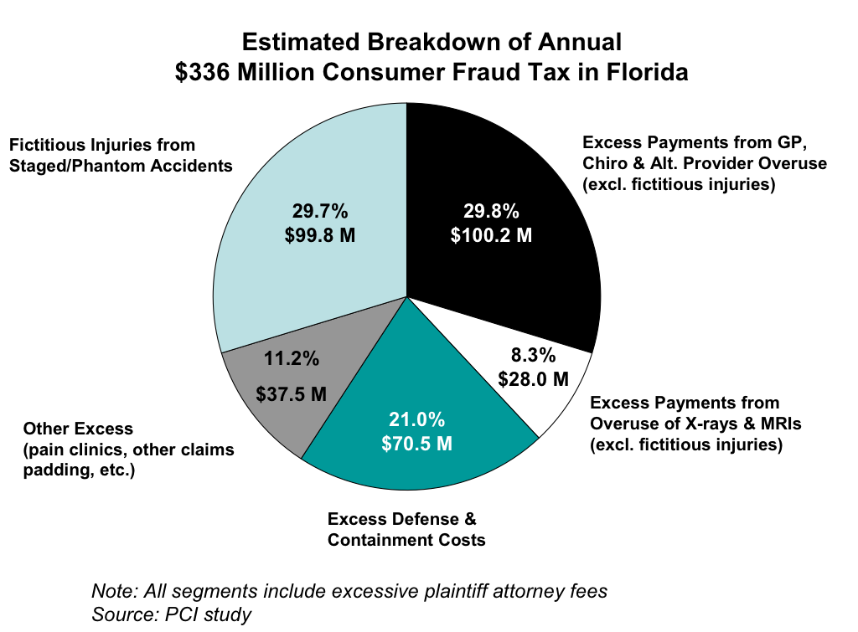

Specifically, the four solutions are as follows:

1. Allow reasonable investigations of suspected fraud

  - The number of questionable auto insurance claims is skyrocketing in Florida. According to the Division of Insurance Fraud of the Florida Department of Financial Services, no fault referrals to the division have more than doubled since 2007, and almost 50% of all referrals are related to no fault claims.

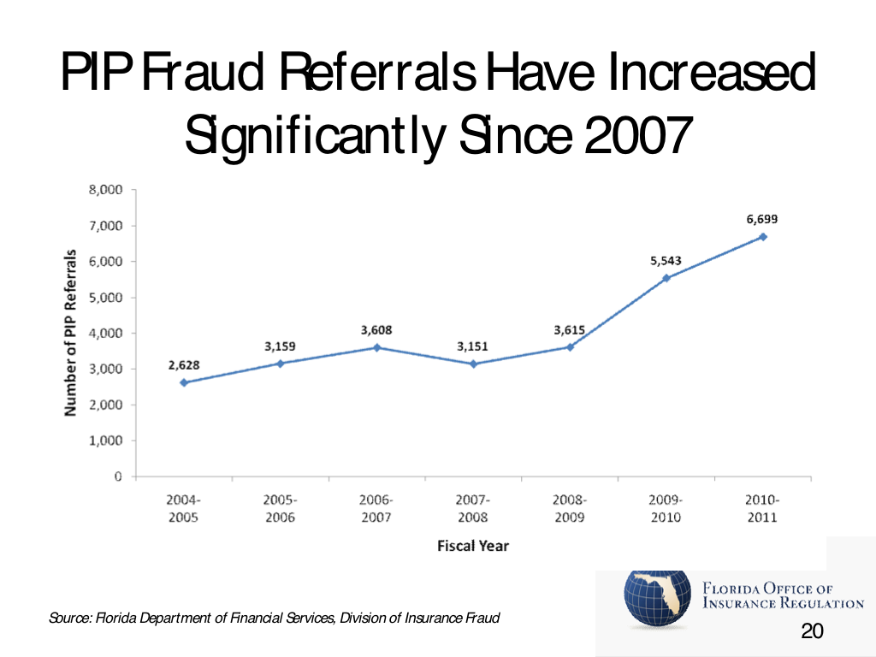

  - Florida’s current no fault system makes it almost impossible for insurers to investigate suspicious claims. While the vast majority of insurance claims are paid in less than 30 days, fraudulent attorneys and claimants have learned to game the system with false delays and threats of bad faith legal action to demand extra bounties.

  - Normal investigative tools such as second opinion medical exams and questioning those making claims for benefits under oath are often evaded by unscrupulous individuals or claims assigned to third party players who are not subject to the same rules. Fixing this problem requires the same rules to apply to everyone, including a requirement to answer claims questions under oath and allowing medical review where appropriate.

2. Eliminate incentives for frivolous no fault law suits

- Florida’s courts are clogged with no fault litigation because trial lawyers filing no fault claims are routinely getting rewarded with bounties up to $500 per hour for their work. Not surprisingly, unscrupulous attorneys can spend years litigating disputes involving minimal amounts. According to the Florida Office of Insurance Regulation, no fault litigation has increased almost five-fold in the past four years, from over 6,000 cases in 2006 to over 28,000 cases in 2010.

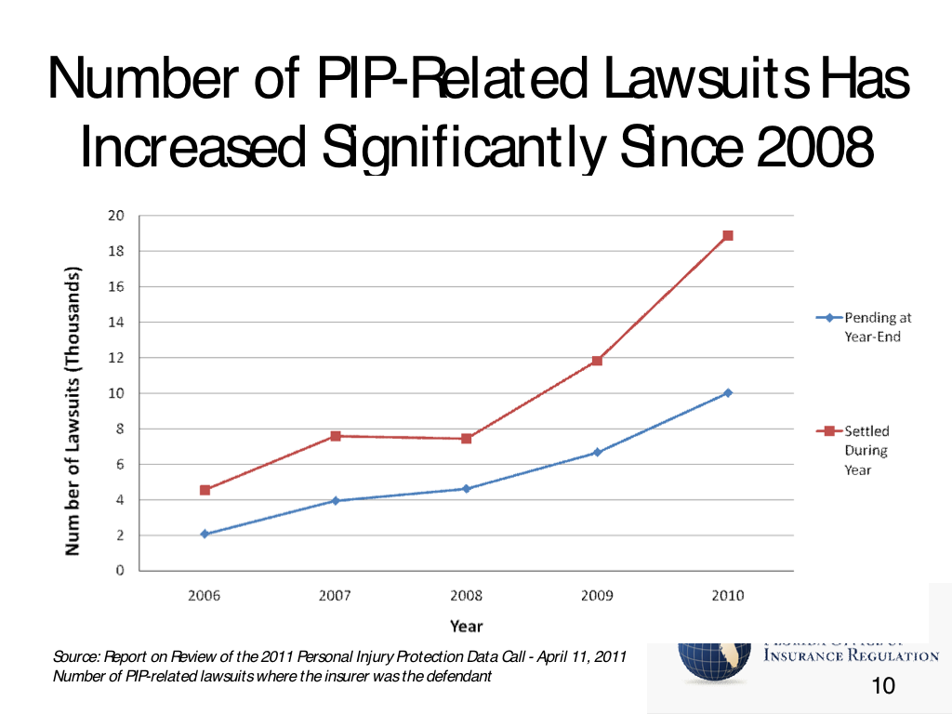

- The incentive to extensively litigate minimal or contrived disputes can be reduced by placing reasonable limits on attorney fees in no fault cases to stop rewarding litigators with jackpot fees of up to 30 times greater than what the average Floridian earns.

3. Provide greater verification of medical clinics

- Fraudulent medical clinics are using loopholes in the states’ clinic licensing laws to avoid oversight, steal business from legitimate hospitals and medical providers, and focus on building up unnecessary services with or without the knowledge of the claimant.

- Fraud by illegitimate medical competitors would be significantly reduced by limiting licensing exemptions from government oversight and allowing insurers to conduct on-site verification inspections to determine if treatments are actually being provided.

- Eight of out 10 Florida no fault claimants (80%) versus 65% of no fault claimants elsewhere have 1 or more diagnostic treatments (e.g., CT scans, MRIs and X-rays) done. These treatments cost more in Florida, too.

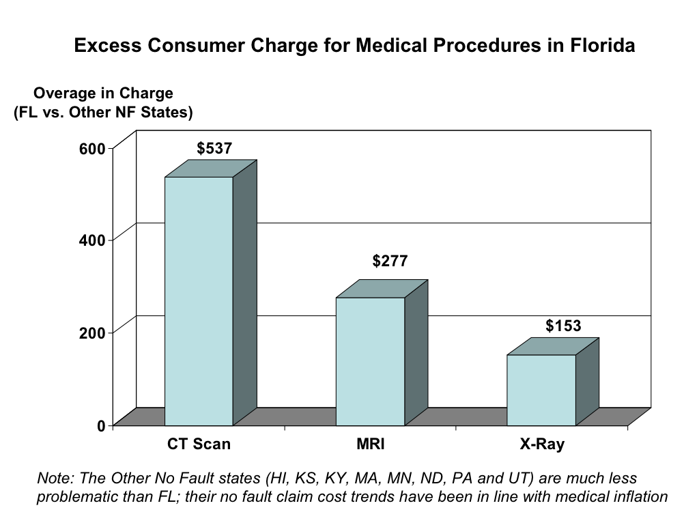

4. Prevent fraudulent “build up” of unnecessary medical treatment

- Overutilization of unnecessary non-emergency care provided by various health providers is a key cost driver in the Florida no fault system. It is imperative to curb overuse by establishing reasonable limits on treatments performed by alternative providers (massage therapists, acupuncturists, naprapaths, naturopaths, etc.), orthopedists, pain clinics, chiropractors, and others.

- Compared to traditional health care providers who treat no fault claimants in Florida, massage therapists, acupuncturists, naprapaths and naturopaths:

○ have 75% more visits per claimant

○ have 83% longer treatment length per claimant

○ charge 40% more and are paid 65% more per claimant

- Overcharges by different health care providers are another key cost driver contributing to high no fault losses. Reasonable limits must be set on provider charges as well.

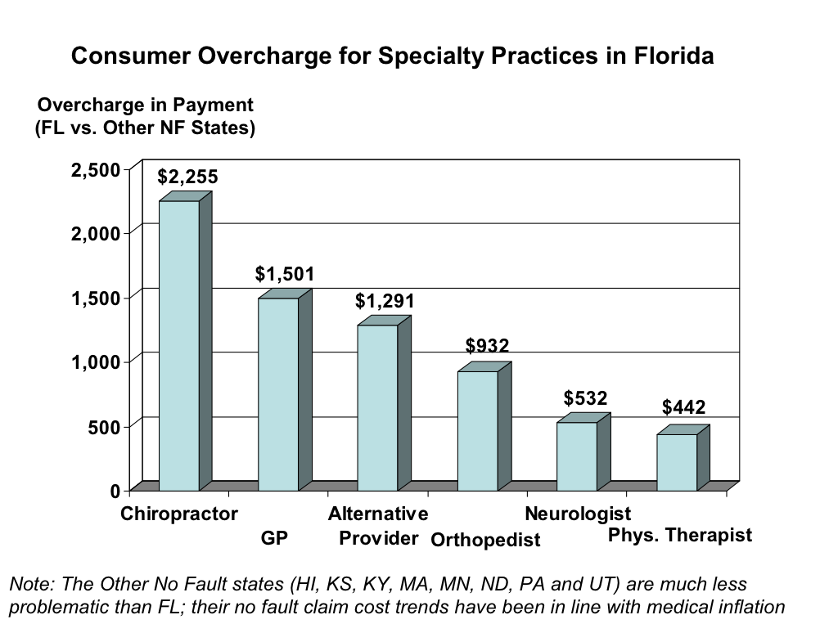

How Will Transformation Benefit Florida Consumers?

- Florida’s skyrocketing no fault costs will be brought under control and slow the rate of premium growth.

- With the incentive of out of proportion fees removed, there will be less litigation of no fault claims, further reducing costs to the system.

- Fraudulent medical clinics and providers will no longer be able to evade investigative tools such as examinations under oath and facility inspections, allowing fraudulent claims to be detected or deterred altogether.

- Reasonable limits on non-emergency care will not only preserve benefits for acute emergency care, but reduce costs by removing incentives for overutilization of non- emergency medical services.

